2020

MockupUI 2
Product Description

Helping software designers to quickly turn ideas into UI mockups.

MIRAFX
17/04/2020
MockupUI 2
MockupUI is a user interface mockup, wireframing and prototyping software. It helps UI designers and developers or any person involved in a software development project to quickly convert ideas into visual mockups and produce design specification documents.
Purpose  - Design user interfaces.  - Formulate clear requirements.  - Illustrate use case scenarios.  - Elaborate design specifications.  - Validate UI design concepts.  - Visualize requirement changes. | Benefits  - Shorter idea to prototype path.  - Convince stakeholders and clients.  - Reduce software design costs.  - Ensure designs achieve requirements.  - Better estimate development efforts.  - No programming skills needed.
Key Features
Create user interface mockups.  - UI widgets ranging from basic buttons and labels to tables and trees.  - Quickly fill tables and trees with text, icons, checkboxes, hyperlinks, buttons and combo-boxes.  - Insert images, graphic text, clipart files and shapes in your designs.  - Instantly change the appearance of widgets from wireframe to native.  - Create, share and re-use design templates. | Create design specification documents.  - Add rich text descriptions and notes to your designs.  - Compile designs and annotations into ready-to-print Word, PDF and HTML documents.  - Copy designs to clipboard and paste them to your documents (Word, PowerPoint, ...).  - Export designs to image files in PNG, JPG, PPM, TIFF or BMP format.  - Preview and print documents directly from MockupUI.  - Create clickable prototypes and interactive demos

What’s new in MockupUI 2
New widgets
- Shapes library: Basic graphic shapes, arrows and callouts
- Icons library: Font Awesome (a set of 368 web icons), Material Design (909 icons from the Google web font), Windows 10 flat design icon set (629 icons)
- Widgets icons: Button, table, tree, list, toolbox widgets can now contain icons
- Toolbar: A new widget that can contain icons, comboboxes, checkboxes, hyperlinks and control buttons
Design area usability
- Select, move, copy, paste or delete multiple objects at once
- Zoom in, out or fit for easier editing
- Snap to grid for easier widget alignment
Generate interactive presentations
- Link any widget to a page
- Generate clickable HTML demos
- Show widget tooltips when hovering with the mouse
System Requirements
Supported operating systems
- Microsoft Windows 8 (64-bit)
- Microsoft Windows 7 (64-bit)
- Microsoft Windows Vista (64-bit)
Minimum system requirements
- Hard disk space: 200MB free disk space for program installation
- Web access: Required for online product activation.
- Processor: 1.4 GHz Intel Pentium 4 or AMD Athlon 64
- Memory: 2GB
- Graphics card: Graphics card with OpenGL support
- Monitor / Display: 17" LCD Monitor
- Screen resolution: 1024 × 768
Recommended system requirements
- Processor: 2.4 GHz Intel Core 2 Quad or AMD Phenom X4
- Memory: 4GB RAM
- Graphics card: Graphics card with OpenGL support
- Monitor / Display: 21" LCD Display
- Screen resolution: 1920 × 1200
Availability
MockupUI is available now and can be downloaded from http://mockupui.com
Examples
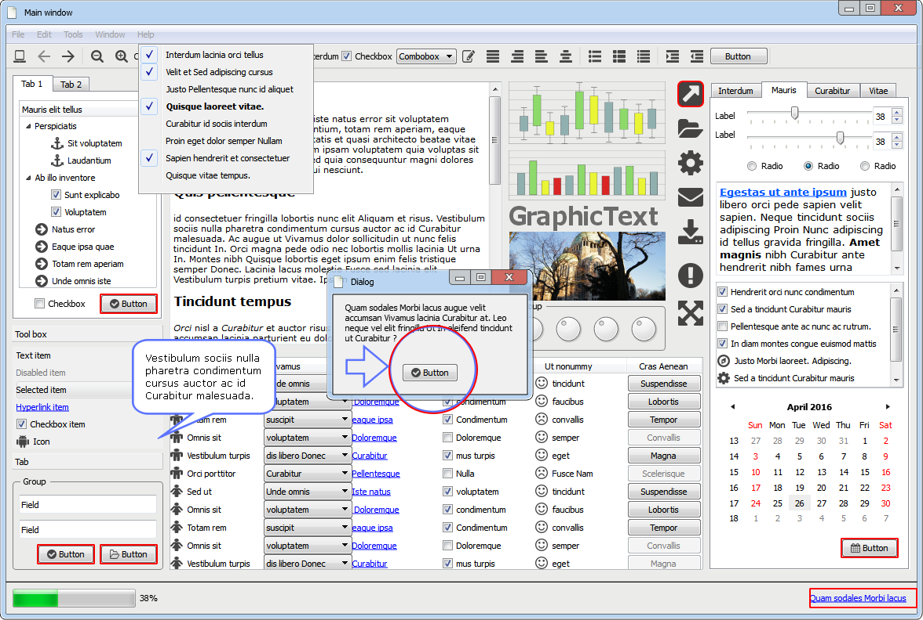

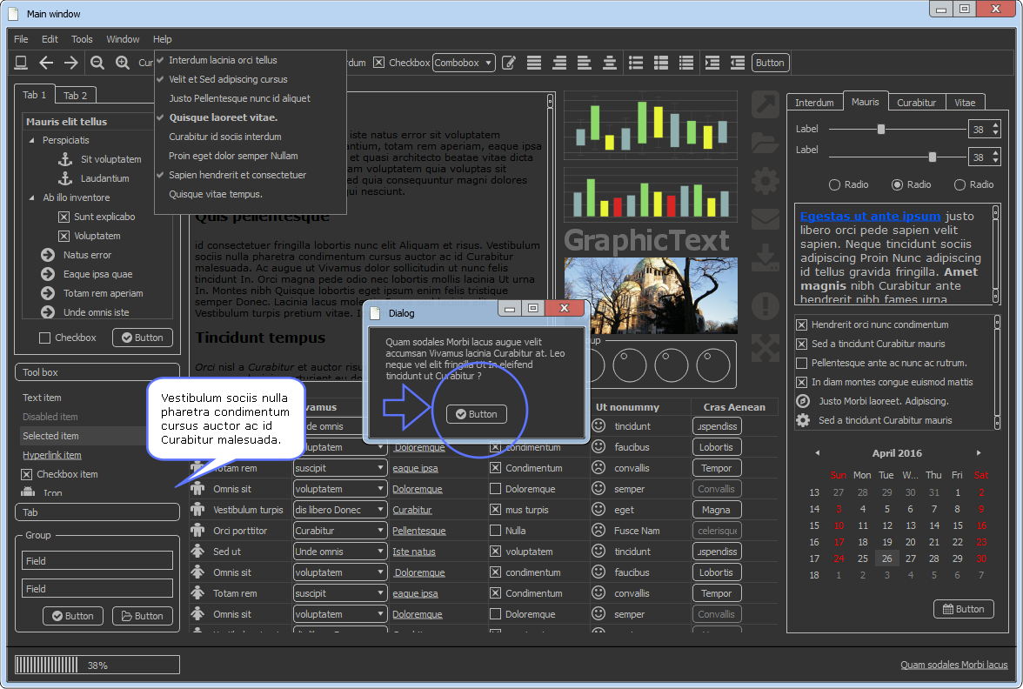
Features in Detail

UI WIDGETS

Common UI widgets.
- Window  - Menu  - Group  - Tab  - Button  - Checkbox  - Radio  - Slider  - Label | - Hyperlink  - Text field  - Spinbox  - Combobox  - List  - Text area  - Dial  - Progress bar  - Calendar | 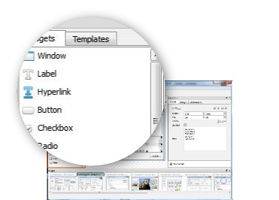

TABLE WIDGET
Design rich UI tables  - Fill tables with data in a CSV-like format.  - Easily add buttons, comboboxes, checkboxes and hyperlinks to cells or entire columns.  - Tick/untick cell checkboxes individually.  - Highlight or disable columns or individual table cells. | 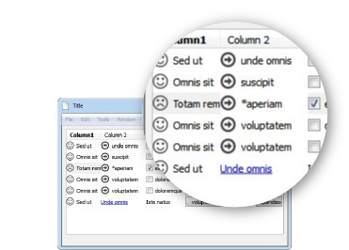

TREE WIDGET
Design simple trees or multi column tree tables  - Add content to trees and tree tables by simply indenting CSV lines.  - Easily add buttons, comboboxes, checkboxes and hyperlinks to items or columns.  - Tick/untick cell checkboxes individually.  - Highlight or disable individual tree items. | 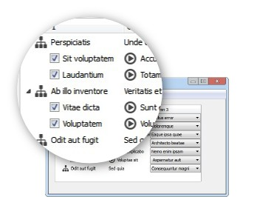

IMAGE WIDGET
Add and edit images into your designs  - Scale, flip, rotate images and adjust their opacity.  - Automatically resize/crop images using a selection of methods (Scale, Fit, Stretch or Fill).  - Change image opacity and blending mode.  - Supported formats: PNG, JPG, PPM, TIFF, BMP. | 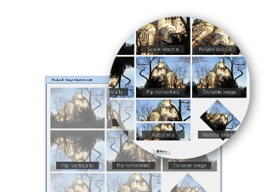

CLIPART WIDGET
Add SVG clipart files to your designs  - Clipart scale, flip, rotate and change opacity.  - Stretch to widget size or preserve aspect ratio.  - Supported file format: SVG. | 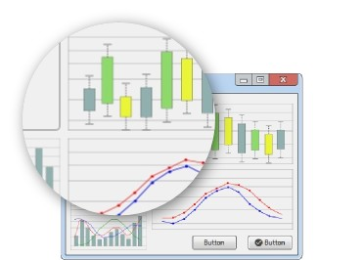

SHAPES
Insert line, rectangle or ellipse shapes into a design  - Line: draws a line inside the widget bounding rectangle.  - Rectangle: draws a rectangle shape.  - Ellipse: draws an ellipse or circle shape.  - Change outline width, color and pattern.  - Fill shapes with solid colors, gradients, patterns or tiles.  - Add text to the center of shapes | 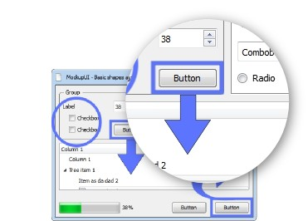

ICONS
Add SVG icons to your graphic mockups  - Font Awesome: A set of 368 web icons  - Material Design: 909 icons from the well known Google web font  - Windows 10: The Windows 10 flat design icon set (629 icons)  - Flip, rotate, resize and change the outline and fill colors of the icons  - Make icons clickable and link them to pages | 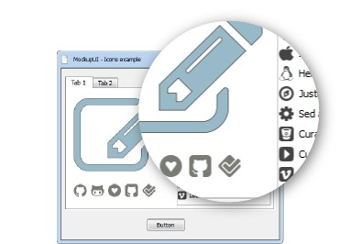

GRAPHIC TEXT
Insert graphic text  - Bold, italic, underline  - Select font, size and color  - Align left, right, center or justified  - Rotate text and set margins  - Preserve font dimensions ratio or stretch to size  - Automatically wrap words  - Change the opacity of the text | 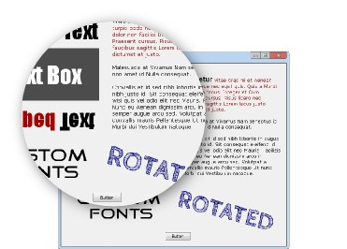

ANNOTATIONS
Annotate your designs and generate specification documents  - Add descriptions and notes to your design screens.  - Paste text content from other sources.  - Format text by applying font, color, emphasis, alignment and bullets. | 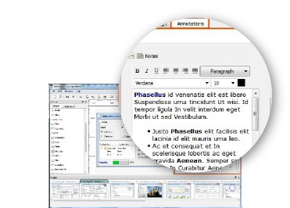

SPECIFICATIONS
Generate design specifications in one click  - Compile designs screenshots and annotations into ready-to-print Word, PDF and HTML documents.  - Preview and print specifications directly from MockupUI. | 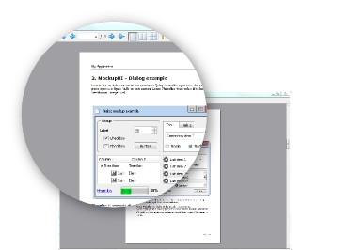

EXPORT
Export designs to multiple formats  - Copy to clipboard and paste the design to your document (Word, PowerPoint or other editing software).  - Export designs to image files in PNG, JPG, PPM, TIFF or BMP format. | 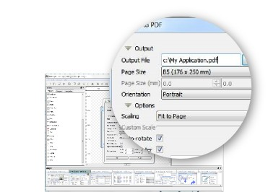

PRESNTATIONS
Create clickable presentations  - Make widgets clickable and add links to pages to implement navigation  - Export designs to HTML with clickable areas | 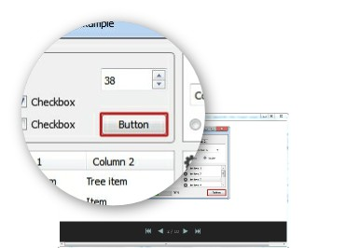

TEMPLATES
Save, re-use and share design templates  - Save designs as templates.  - Create a design from a template.  - Import and export templates from your project. | 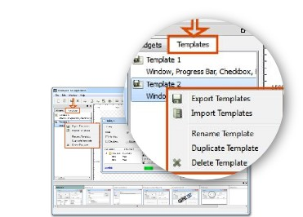

VISUAL STYLES
Customize the appearance of widgets  - Wireframe look for lo-res prototyping.  - Native operating system look (Windows 7, Vista, XP or Classic).  - Widget colors, fonts and formatting from your current operating system theme.  - Change the appearance of all designs at any time in one click. | 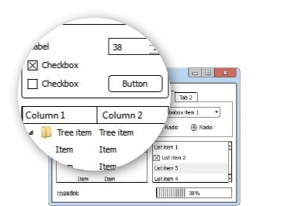

DESIGN AREA
Edit widgets visually  - Drag and drop widgets from a toolbox  - Adjust widgets dimensions and position  - Snap to grid for easier widget alignment  - Scroll the design area from left-right, top-bottom  - Zoom in, out or fit for easier editing | 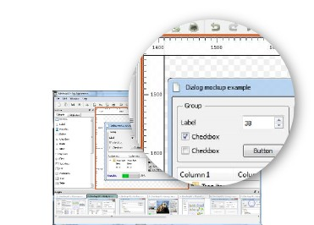

PROJECT
Organize designs into projects  - Create, preview, rename, duplicate and reorder designs in a project.  - Open multiple projects simultaneously and copy/paste widgets from one project to another.  - Unlimited number of designs per project.  - Auto-save project file for backup purposes. | 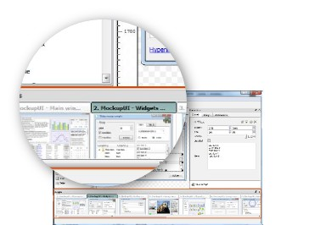

SUPPORT
Free access to our support pages  - Free 12 month support and software updates.  - Access to the reference manual, FAQ and other free online resources. | 